Supplementary Materials

PBVHx Nanoparticle-Mediated Ginsenoside Rg3 Nanocarriers Enhance Osteogenic Differentiation of Stem Cells

Chengjian Cao^{1†}, Fang Zhang^{1†}, Juan Tang¹, Dechao Yuan², Fuqiang Shao³,
Chenyuan Wang³, Shiwei Liu²**, Dai-Xu Wei¹*
1 Zigong Academy of Medical Sciences, Zigong First People's Hospital, No. 42, Shangyihao No.1 road, Ziliujing District, Zigong, Sichuan, China
2 Department of orthopedics,Zigong First People's Hospital, No. 42, Shangyihao No.1 road, Ziliujing District, Zigong, Sichuan, China
3 Department of Nuclear Medicine, Zigong First People's Hospital, No. 42, Shangyihao No.1 road, Ziliujing District, Zigong, Sichuan, China

†These authors contributed equally to this work.

Corresponding author:
*Prof. Dai-Xu Wei, E-mail address: daviddxwei@163.com
**Dr. Shiwei Liu, E-mail address: lsw8896l79@163.com

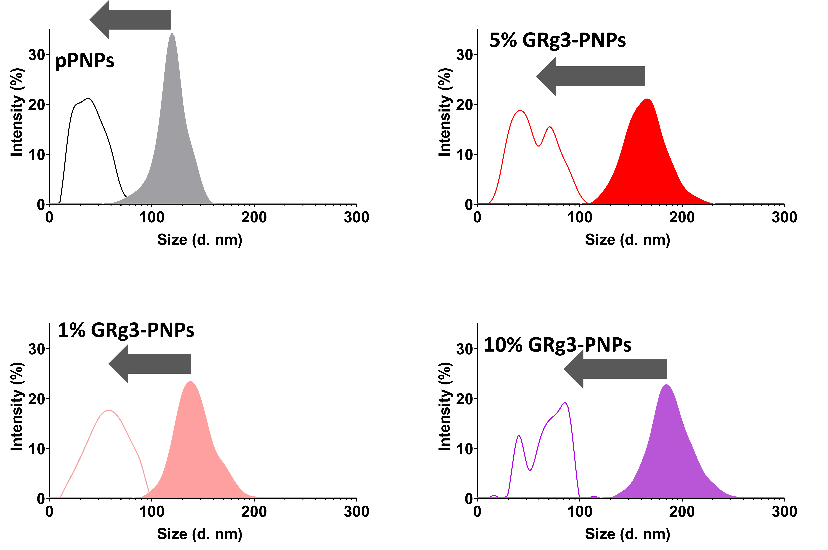
Fig. S1. Comparison of the size distribution of pPNPs, 1% GRg3-PNPs, 5% GRg3-PNPs, and 10% GRg3-PNP, respectively, on Day 0 and Day 20 in Degradation. The size distribution on the left corresponds to Day 0, and the right to Day 20.

